## 

## Merchant

Scoping start date: Oct 18, 2023

MSA Signature Date: Nov 12, 2024  
Onboarding Kick Off Date: Nov 13, 2024

[If Exists] Opt Out Date: none  
Go Live Date: Dec 15, 2023

GTM POC: Jarrett  
Implementation POC: Royce

ERP: QBO

Tax Integration: No Tax Moving to Avalara

### 

### Key people at Merchant

### Accountant:

### [Seth Johnson](mailto:seth@howard-financial.com)is the Fraction accountant who was newly hired.

### Mouricio is the fractional accountant

### Etc.

### 

| Notes Sections [Ops International Team to Ignore] *(AE/ Implementation to fill)*   * Info on how merchant bills   + The vast majority of their contracts are monthly agreements that act like Saas. The rest are one-off. * Is there any important merchant relationship information?  1) **What is the merchant temperament?** Seth is very pro Tabs and is tasked with cleaning up Autumn- he’s tech-forward and moves fast  2) **Is there a key POC: (i.e.: who is the buyer/decision maker?)?** Seth selected the hardware stack, and Howard will be primarily interfacing with the Tabs team. Autumn was the signee but will otherwise be uninvolved   3) **What are the Tabs features that the key POC cares about?** Billing, Stripe free passing, renewal tracking |
| --- |
|  |

### 

### Company summary *(AE to fill)*

Autumn is a full-service, nationally integrated PR & Creative Marketing agency that amplifies brands in unexpected, inspiring, and impactful ways.

Goals (North star)  
*(AE/ Implementation to fill)*

What is the merchant's goal? What pain are we solving? Why are they buying Tabs?

**Seth is a fractional accountant at Howard tasked with cleaning up the books at Autumn. He’s responsible for several key items:**

* **Ensuring they are billing the correct amounts**
* **Tracking renewals**
* **Transferring all recurring billing to autopay**

Is there an opt out clause? If so, what is the merchant looking for so they do not exercise it?

* **No**

### Billing model *(AE/ Implementation to fill)*

* **The vast majority of their contracts are monthly agreements that act like Saas. The rest are one-off**

### Contract Processing Steps *(Implementation/Success to fill)*

1. **Steps to process**
   1. **If there is only ONE contract and NO amendment for a customer follow the steps below:** *(see an example for Society 6 below) Refer to this* [*garage link*](https://garage.tabsplatform.com/prod/contracts/b13f1739-90d8-4c43-96c0-97e9e623adf2/terms/key) *to see an example of processing* [*Please watch this loom video to follow along*](https://www.loom.com/share/89dca9da736c4d5bb9ac85ec3e0d23c9?sid=7f3d363d-10ea-48d6-85b9-fd1b26ad086c)
      1. Service Start Date: Refer to *Agreement Effective Date*
      2. If there are TWO dates here, make TWO revenue schedules for each naming convention. Put the name of what comes after the date in the Item description section. See the example screenshot below. There will be a total of 3 revenue schedules made, one for PR, Affiliate, and First/Last Months payment
         1. Make the following revenue schedules
            1. Revenue Schedule 1-Item Description: PR
            2. Revenue Schedule 2- Item Description: Affiliate
            3. Revenue Schedule 3 - First and Last Month

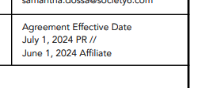

* + 1. Default Item Name: Services
    2. Default Integration Item: PR Services or Affiliate (Depeneding on which one you are processing)
    3. Refer to section 5.1 for pricing information for PR and Affiliate

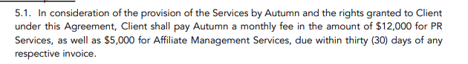

* + - 1. For Revenue Schedule 1 (PR)
         1. Total Price: See Contract (example: $12,000)
         2. Total Months of Service: length of contract
         3. Quantity:1
         4. Periods: Same as Months of Service
         5. Frequency: 1 month
         6. Net terms: 30
      2. For Revenue Schedule 2 (Affiliate)
         1. Total Price: See Contract (example: $5,000)
         2. Total Months of Service: : (Total Month Term - 2 months for First/Last Month Payment) 4 months
         3. Quantity: 1
         4. Periods: Same as months of service
         5. Frequency: 1 month
         6. Net terms: 30
    1. Refer to section 5.2 for pricing information
       1. Make Revenue Schedule #3 for this item
       2. Service Start Date: Earliest Agreement Effective Date
       3. Total Months of Service: TOTAL LENGTH OF SERVICE
       4. Item Description: First and Last Month
       5. Total Price: Amount listed below (example: 34,000) (2 months of PR and Affiliate)
       6. Periods: 1
    2. If there is NO Section 5.1 / 5.2
       1. Frequency: 1 Month
       2. Net Terms: Net10

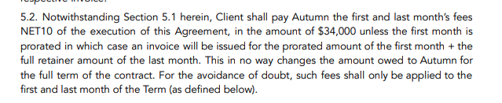

* + 1. For contract length term: search for “Term” in contract

[**Please view loom for instructions below**](https://www.loom.com/share/eb76e2d1751e431d8ac785e0c0a2d22e?sid=8139a770-0392-4ead-a2c6-f0e746c9090e)

* 1. **If there is more than 1 contract for each customer, follow the steps below***(see screenshot of what this would look like in Garage) Pease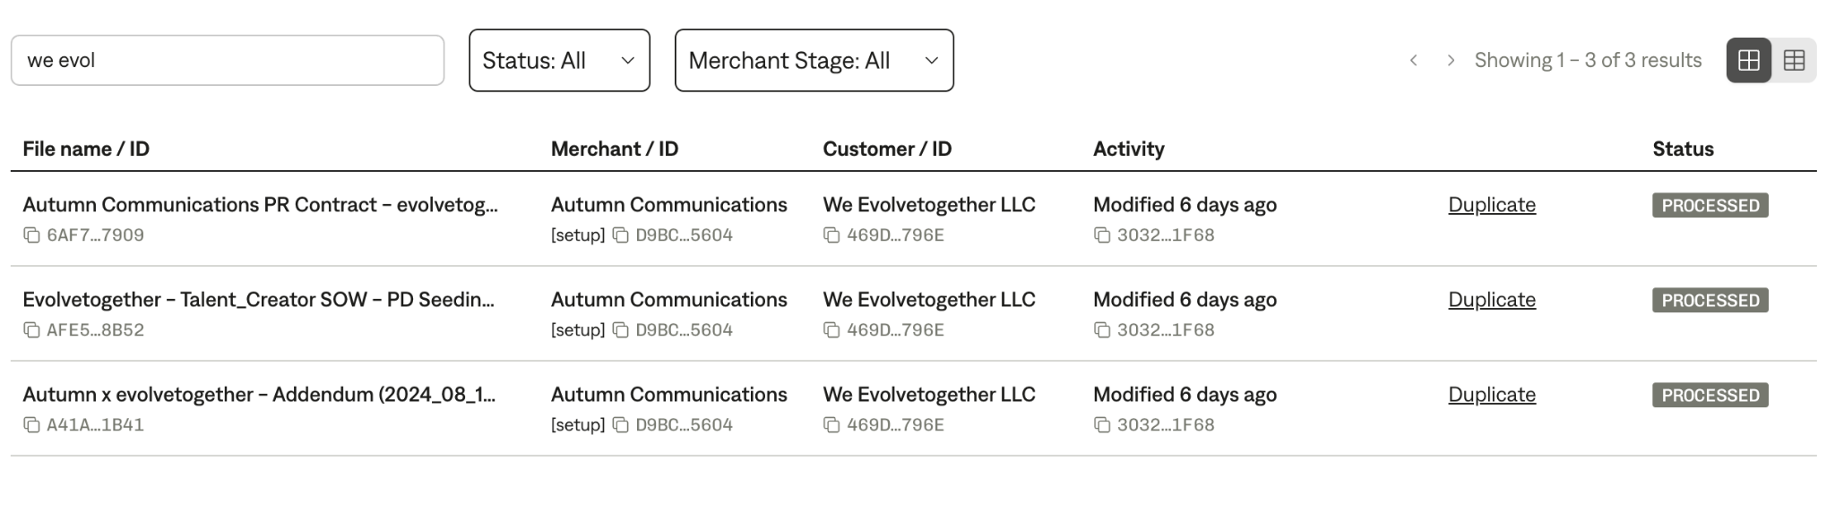*
     1. *Refer to this* [*garage link*](https://garage.tabsplatform.com/prod/contracts/6af7800a-13a4-43c8-b846-9689c3bc7909/terms/key) *to see an example of processing*
     2. First- You must organize all the contracts from earliest to latest. You will have to click on each contract and see which one is the earliest one. Once you find the first original contract, follow the steps below:
        1. Service Start Date: Refer to *Agreement Effective Date*
        2. If there are TWO dates here, make TWO revenue schedules for each naming convention. Put the name of what comes after the date in the Item description section. See the example screenshot below. There will be a total of 3 revenue schedules made, one for PR, Affiliate, and First/Last Months payment
           1. Make the following revenue schedules

Revenue Schedule 1-Item Description: PR

Revenue Schedule 2- Item Description: Affiliate

**

* + - 1. Default Item Name: Services
      2. Default Integration Item: “Last Month’s Retainer”
      3. Refer to section 5.1 for pricing information for PR and Affiliate



* + - * 1. For Revenue Schedule 1 (PR)

Start Date: ONE MONTH AFTER CONTRACT START DATE- Please make note of this

Total Price: See Contract (example: $12,000)

Frequency for the first BT for first and last month: 1 every 1 month

Frequency for the second BT for remaining months if 1 month paid upfront: (total service term in months)-(1)

For example: if the term is 6 months, the first BT will be 1 every 1 month and the second BT will be 5 every 1 month

Frequency for the second BT for remaining months if 2 months paid upfront: (total service term in months)-(2)

For example: if the term is 6 months, the first BT will be 1 every 1 month and the second BT will be 4 every 1 month

Quantity:1

Periods: Same as Months of Service

Frequency: 1 month

Net terms: 30

* + - * 1. For Revenue Schedule 2 (Affiliate)

Start Date: ONE MONTH AFTER CONTRACT START DATE

Total Price: See Contract (example: $5,000)

Total Months of Service: : (Total Month Term - 2 months for First/Last Month Payment) 4 months

Quantity: 1

Periods: Same as months of service

Frequency: 1 month

Net terms: 30

* + - 1. Refer to section 5.2 for pricing information
         1. Make Revenue Schedule #3 for this item
         2. Start Date: ONE MONTH AFTER CONTRACT START DATE
         3. Total Months of Service: 1
         4. Item Description: First and Last Month
         5. Total Price: Amount listed below (example: 34,000) (2 months of PR and Affiliate)
         6. Periods: 1
         7. Frequency: 1 Month
    1. Once you have completed the FIRST contract uploaded, find the second contract following the date of the first one. It will be called something like “ADDENDUM TO PR SERVICES AGREEMENT”. Be sure to have the most recent contract up as you will refer to this for pricing purposes.

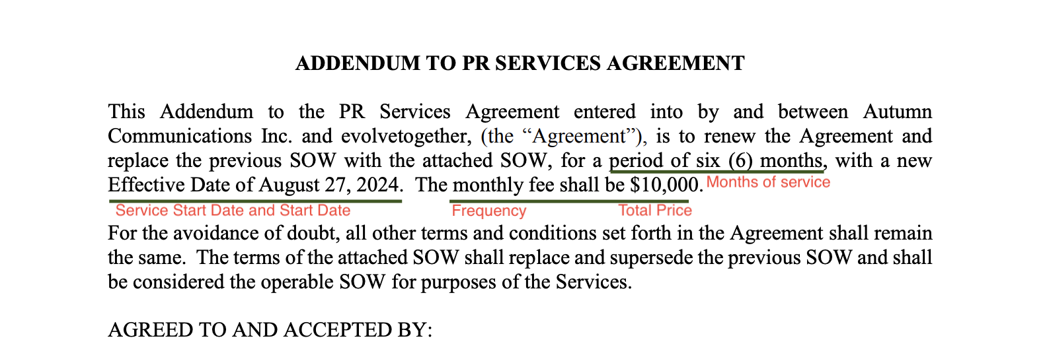

* + - 1. Please see the screenshot (Addendum to PR Services Agreement) above as it will guide you through things to fill out:
         1. Service Start Date: Check the Red text in the screenshot above for “Service Start Date” and put the date listed
         2. Months of Service: Check the Red text screenshot above for “Months of Service” and put the amount listed
         3. Item Name: Default Services
         4. Integration Item: Default PR Services
         5. Total Price: Check the Red Text in the Screenshot Above for the “total price” and put the amount listed
         6. Start Date: Check the Red text in the screenshot above for “Start Date” and put the start date listed
         7. # of Periods: Same as Months of Service
         8. Frequency: Check the Red Text in the Screenshot Above for “frequency” and put the amount listed
         9. Default Net Terms: Net30
      2. If pricing, net terms, frequency, or any other items are not listed copy and paste the same amounts from the previous contract in the fields. The only change will be SERVICE START DATE and START DATE

1. **Anything to ignore in contracts?**
2. **Specifics processing things the merchant has requested that may differ by contract (e.g. always back-date invoice date to the final day of the month)**
3. **Default Service Term**
   1. **If None Listed, Ops Default is 1 Year**
4. **Default Net Payment Terms** 
   1. **Default: Net 30**
5. **Default Billing Frequency** 
   1. **If None Listed, Ops Default is Monthly**
6. **How do we handle taxes as a line item?**
   1. **If None Listed, Ops Default is every tax line item becomes a BT**

### Events Processing (if necessary) *(Implementation/Success to fill)*

* Any important information on events billing

Integration Items Processing (if necessary)  
*(Implementation/Success to fill)*

* What are the instructions for assigning integration items?
* Example: All Statsig integrations items should be labeled as “Sales”
* Example: All “Pinata” integration items should be labeled as “Software Subscription Bundle” unless otherwise noted by Merchant

Post Processing Communications (if necessary)  
*(Implementation/Success to fill)*

* Does the Ops Team need to notify anyone on the team re: completion of processing batches in Implementation or Active phase?
* Who needs to be notified and when?
  + Example:
    - Who: Customer Success [Azmat Aziz] needs to be notified
    - Where: Messari internal merchant channel
    - When: contracts are processed [Merchant Phase: Active]

### Customer Information *(Implementation/Success to fill)*

* Any important information on specifics customers of this merchant
  + Special memo’s certain invoices require
  + Invoice changes due to merchant/customer relationship

### Feature Requests *(AE/Implementation/Success to fill)*

* FR 1
  + What is it
  + Why it's important
  + Urgency

### Rewatch Calls *(AE/Implementation/Success to fill)*

* Rewatch by dates